8.11: a) With 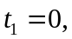

which is 18.8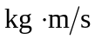, and so the impulse delivered between t=0 and 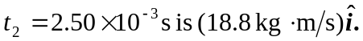 b) the impulse is 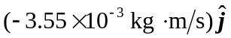 c)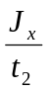=7.52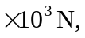 so the average force is (7.52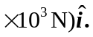

d) 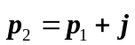
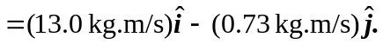

The velocity is the momentum divided by the mass, or (89.7 m/s) 